**Caleb:Users:Caleb:Desktop:need-feed-lowres.jpg**

**HOMEPAGE LIST**

* Displays posts from 5 categories and “ALL” is the default category (The red Prayer tab gets its own separate page due to the larger amount of posts it will receive)Caleb:Users:Caleb:Desktop:Screen shot 2011-05-18 at 5.37.18 PM.png
* Clicking on a colored filter tab filters the list to a single category
* Clicking the “All” category brings in all feeds together sorted as the time they were posted

Caleb:Users:Caleb:Desktop:Screen shot 2011-05-18 at 5.39.27 PM.png

* The numbers on the colored tabs represent the amount of posts in that category that have not yet been viewed/loaded
* Each post has a colored label, and colored buttons that match the corresponding tab
* Each post also displays the users profile picture, First Name, Time Stamp, and “REPORT” (there is a default profile picture for those who don’t have a picture yet). Reporting a post displays in the admin settings where the admin can delete the post, or ban the user

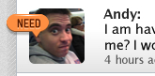 

* Mousing over each post enables a style that has darker text styles and buttons that are fully visible (posts in the off state appear transparent)
* Clicking on the users profile picture or name (above posting), brings you to a list of all their posts
* Posts can also display photos. Clicking on the photo button brings up a lightbox with arrows to cycle through up to three upload photos

Caleb:Users:Caleb:Desktop:Screen shot 2011-05-18 at 6.11.24 PM.png

* Clicking on an action button slides out a phone number or email (plain text)

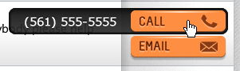

* Users get to choose whether to have phone or email as their contact method (or both), and can choose a preferred contact method (buttons are sorted by preference)
* Users can delete their own posts by clicking on the X in the top right of each of their posts

Caleb:Users:Caleb:Desktop:Screen shot 2011-05-18 at 5.58.51 PM.png

* Scrolling down the page to the bottom brings you to a “Show more Results” button, that when clicked loads more results belowCaleb:Users:Caleb:Desktop:Screen shot 2011-05-18 at 5.36.41 PM.png

**HOMEPAGE FILTER**

* The filter has tabs for sorting, as well as the ability for a user to add a new post
* The first posting field is a drop down that asks for a category (“Need”, “Free”, “Job”, or “Prayer”)

Caleb:Users:Caleb:Desktop:Screen shot 2011-05-18 at 5.26.29 PM.png

* Since “Prayer” is separate, posting a new Prayer post will automatically show prayers list (instead of “All”)
* The next posting filter is “Message”. Each Message is allowed 200 characters (much like twitter). As the user types out the message, the character count dwindles

Caleb:Users:Caleb:Desktop:Screen shot 2011-05-18 at 5.25.45 PM.png

* The user can also post up to three photos by clicking the add photo button. A modal window will pop up and help the user upload up to 3 photos that fit inside file size and type (uploading photos resizes them to more web friendly versions. Once uploaded, the modal window closes and finally marks a number next to the photo button before posting button is clicked)

Caleb:Users:Caleb:Desktop:Screen shot 2011-05-18 at 5.25.17 PM.png

* Hitting Enter or clicking post finally adds the post to the list and reloads the page

Caleb:Users:Caleb:Desktop:Screen shot 2011-05-18 at 5.27.52 PM.png

**SEARCH**

* Users can search Names as well as post keywords

Caleb:Users:Caleb:Desktop:Screen shot 2011-05-18 at 5.29.12 PM.png

* Hitting Enter or clicking search reloads the page with search results (search results are styled as a regular posts)

**LOGO**

* Clicking logo brings you to the homepage (“ALL” category)
* The church name next to logo can be changed by the admin as dynamic text
* Beta logo will be for first church project only. This will be a special admin field, or removed by developers.

Caleb:Users:Caleb:Desktop:Screen shot 2011-05-18 at 5.44.27 PM.png

**USER DROP DOWN MENU**

* Once logged in, a user Drop Down menu appears. This menu has a small thumbnail of the user profile followed by “Hello, Username” and a finally the dropdown arrow

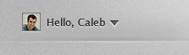

* When a user is not logged in, The menu reads “Log In Here”
* Logging in automatically “Remembers” the user in further use

**USER SETTINGS**

* Once a user is logged in (via lightbox style modal window), they are brought to an interior settings page with side navigation

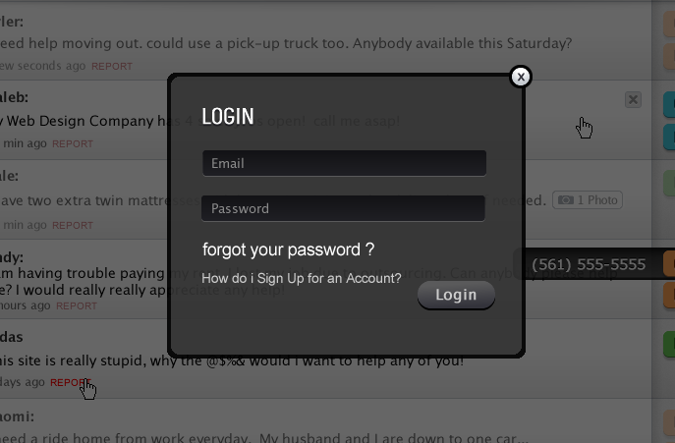

* Users can change password, update their profile photo, choose their contact preferences, view their posts, grab RSS codes from all 5 feeds (all counts as a feed), and change their password

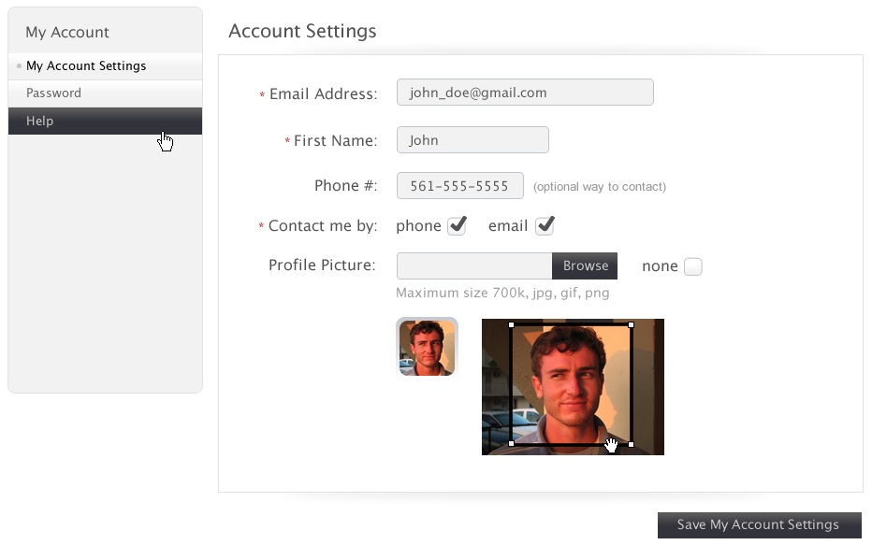

* Resetting password is simple and doesn’t require a notification email. Once new password is set, the page reloads and a confirmation message

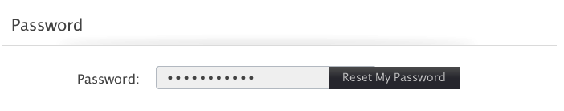

* After uploading a photo (must meet the size and file type requirements), the user can crop out a constrained ratio sized thumbnail

**ADMIN SETTINGS**

* The admin has the ability to view/monitor current amount of posts, change the church name, set the post expiration dates (can save valuable storage space), add/remove users, check for updates, and view a help page
* Updates and Help page are iframes that point to the main NEEDFEED.org pages (allowing for easy message and updates without require an overall software update)
* (The admin can also post and have all the same settings and abilities as a normal user)

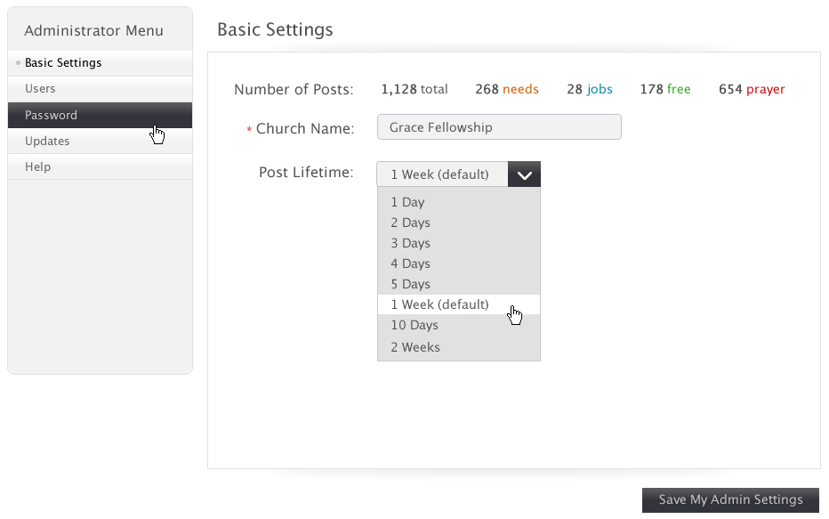

**MEMBERSHIP**

* Membership is only available to new church members
* To add a user, the admin must create the username and password (not automatically generated)
* There can be up to 5 multiple admin accounts, only able created when software is being set up for the first time

**INSTALLATION**

* The complete software package needs to be available as a download .pdf.
* The software package can be downloaded from the main .org website (not included in this scope)
* The software needs to be written in an easy to install, easy to manage, flexible language
* The software will site on a churches website server and will be installed by the churches webmaster
* Keeping this as simple as possible is the key, and I am open to suggestions to make this part smoother
* A main purpose of this software is to make it free for everyone, and easy to use
* This also needs to be installed in a way that blocks Google search indexing (keeping names and needs private)

**COLATERALS**

* All finished pages designs will be supplied. From the favicon to the apple touch, all graphics will be provided. Any other necessary graphics can also be requested and supplied in a timely manor. Page Designs are designed in a Fireworks .png, but can also be exported as a .psd